**Difference between Document and Window Objects?**

In JavaScript, knowing the roles of Document and Window objects is key. They shape web pages and how scripts interact with them. Let's explore their differences and functions.

**Window Object:**

**Global Scope:** Represents the browser window or tab.

**Browser Interaction:** Accesses browser-specific properties and manages the browser.

**Lifecycle Management:** Handles window events and inter-window communication.

**Window Object Example:**

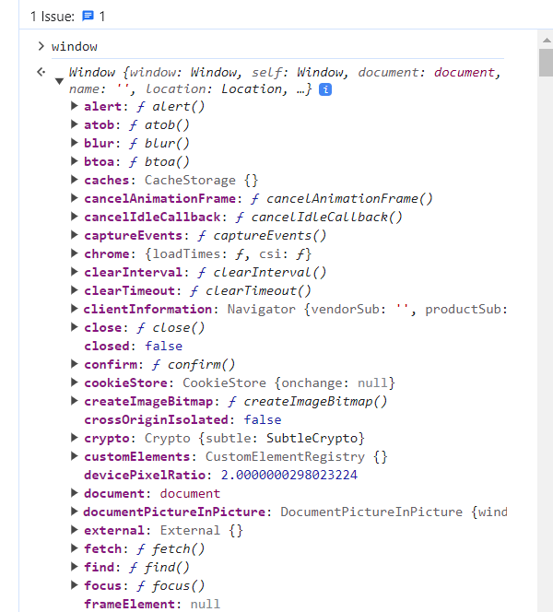

**Window object which already contains document objects itself:**

**Document Object:**

**Page Content:** Represents the web page content within a window.

**DOM Manipulation:** Accesses and manipulates page elements and structure.

**Event Handling:** Manages events occurring within the document.

When an HTML Document is loaded into a web browser, it becomes a document object.

The document object is a property of the window object.

**Example: Document Object**

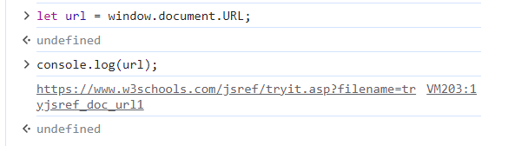

**Document object also has its own properties and methods.**

**But Normally document can be view as content of the website:**

**Differences:**

**Scope:** Window encompasses the entire browser, while Document represents page content.

**Access:** Window manages browser-related properties, while Document deals with page-specific elements.

**Hierarchy:** Document is nested within the Window object.

Understanding these objects' roles aids in dynamic web development, enabling effective interaction with browser and page content.